# Brainstorm

### Before you collaborate

A little bit of preparation goes a long way with this session. Here’s what you need to do to get going.

**10 minutes**

**1**

### Define your problem statement

Phishing is a major problem, which uses both social engineering and technical decetion to get user's important information such as financial data, emails, and other private information.

**5 minutes**

**2**

### Brainstorm

Write down any ideas that come to mind that address your problem statement.

**10 minutes**

**3**

### Group ideas

Take turns sharing your ideas while clustering similar or related notes as you go. Once all sticky notes have been grouped, give each cluster a sentence-like label. If a cluster is bigger than six sticky notes, try and see if you and break it up into smaller sub-groups.

**20 minutes**

**4**

### Prioritize

Your team should all be on the same page about what's important moving forward. Place your ideas on this grid to determine which ideas are important and which are feasible.

**20 minutes**

### After you collaborate

You can export the mural as an image or pdf to share with members of your company who might find it helpful.

**Quick add-ons**

# & idea prioritization

**PROBLEM**

How might we find the phishing websites?

Use this template in your own brainstorming sessions so your team can unleash their imagination and start shaping concepts even if you're not sitting in the same room.

1. **Team gathering**

Define who should participate in the session and send an invite. Share relevant information or pre-work ahead.

1. **Set the goal**

Think about the problem you'll be focusing on solving in the brainstorming session.

1. **Learn how to use the facilitation tools**

Use the Facilitation Superpowers to run a happy and productive session.

**Balasubramanian R**

Alwys make use of softwares upto date

Detecting duplicate websites

Frequently change your password and provide strong password

**Iyyappan P**

## 

Live monitorization in detection

Creating database for storing infected websites

**Protection**

Avoid tempted by pop- ups

Anti-Phishing tools are used to detect the spam or fraud websites

Adding Extensions on such browser to intimate the warning in entry of spam links

**Detection**

**Prevention**

The links should pass the whitelist and blacklist to get clear idea about the link

1. **Share the mural**

**Share a view link** to the mural with stakeholders to keep them in the loop about the outcomes of the session.

1. **Export the mural**

Export a copy of the mural as a PNG or PDF to attach to emails, include in slides, or save in your drive.

Storing the predicated results in cloud

Any classification algorithm can be used for prediction

Use of custom ensemble technique

Enhancing the security algorithms

Don't click unwanted sites and notification to avoid the trap of attackers

**10 minutes** to prepare

**1 hour** to collaborate

**2-8 people** recommended

[**Open article**](https://support.mural.co/en/articles/2113740-facilitation-superpowers)

**Key rules of brainstorming**

To run an smooth and productive session

**Abitha C**

Use Anti- Phishing protection

Avoid cllicking the unknown URL

**Sathya Prabha M**

Improving RNN

classification

Identify anomalies

**Keep moving forward**

**Strategy blueprint**

Define the components of a new idea or strategy.

[**Open the template**](https://app.mural.co/template/e95f612a-f72a-4772-bc48-545aaa04e0c9/984865a6-0a96-4472-a48d-47639307b3ca)

**Customer experience journey map**

Understand customer needs, motivations, and

Avoid clicking spam mails

Stay in topic. Defer judgment.

Encourage wild ideas. Listen to others.

**Importance**

Aware of fake DNS names from such similar names

The links shold pass the whitelist and black list to get clear idea about the link

Installation of anti-phishing software to detect the man- in middle attack

If each of these

obstacles for an experience.

[**Open the template**](https://app.mural.co/template/b7114010-3a67-4d63-a51d-6f2cedc9633f/c1b465ab-57af-4624-8faf-ebb312edc0eb)

Use firewalls for protection

Adding extensions on such browser to intimate the warning in entry of spam links

Go for volume. If possible, be visual.

tasks could get

done without any difficulty or cost, which would have the most positive impact?

Protect the system from attacks by taking backup of such personal data

Effective algorithms to detect the phishing websites

Ensure that the links are secure which is based on SSL certification

**Strengths, weaknesses, opportunities & threats**

Identify strengths, weaknesses, opportunities, and threats (SWOT) to develop a plan.

|  |  |
| --- | --- |
|  |  |
|  |  |

[**Open the template**](https://app.mural.co/template/6a062671-89ee-4b76-9409-2603d8b098be/ca270343-1d54-4952-9d8c-fbc303ffd0f2)

[**Share template feedback**](https://muralco.typeform.com/to/CiqaHVat?typeform-source=app.mural.co)

Ensure that the links are secure which is based on SSL certification

Maintain and secure your's credit & debit cards details

Do not link your accout details for third-party apps &websites

Mostly avoid HTTP

websites and use HTTPS websites

Undersamping or oversampling can be carried out

Changing Password regularly

[**Share template feedback**](https://muralco.typeform.com/to/CiqaHVat?typeform-source=app.mural.co)

**Feasibility**

Regardless of their importance, which tasks are more feasible than others? (Cost, time, effort, complexity, etc.)

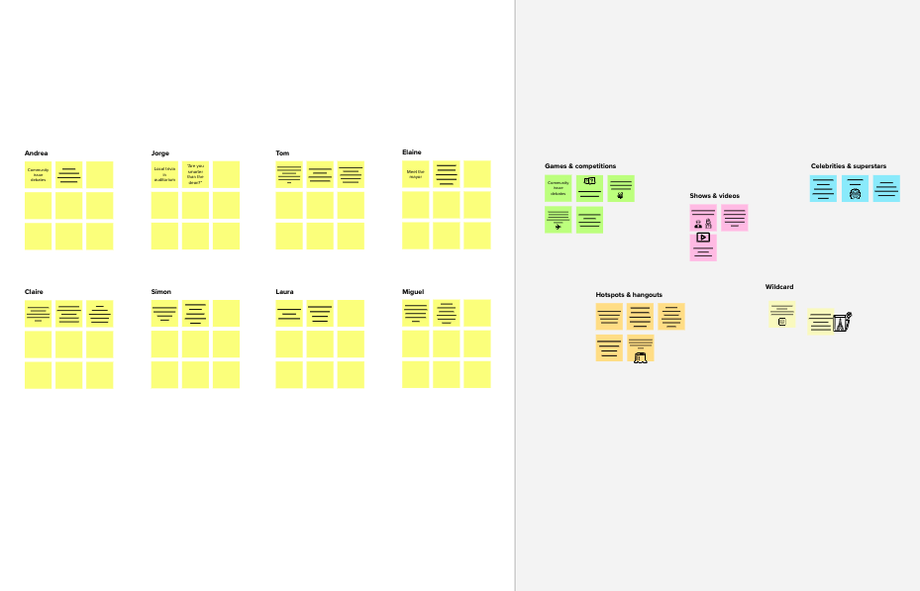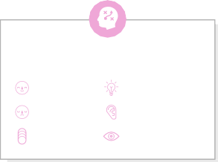

**Template**

**Need some inspiration?**

See a finished version of this template to kickstart your work.

[**Open example**](https://app.mural.co/template/e5a93b7b-49f2-48c9-afd7-a635d860eba6/93f1b98d-b2d2-4695-8e85-7e9c0d2fd9b9)